EA02-TNPID
TYPE YOUR SPECIFIC PAPER TITLE HERE: ARIAL, 16 BOLD, CENTERED

First Given Name Surname (Arial, 10 Bold)
line 2: dept. name of institute / University (Arial, 10)
Institute / University Name
City, Country
email@website.com
First Given Name Surname
line 2: dept. name of institute / University
Institute / University Name
City, Country
email@website.com

First Given Name Surname
line 2: dept. name of institute / University
Institute / University Name
City, Country
email@website.com
First Given Name Surname
line 2: dept. name of institute / University
Institute / University Name
City, Country
email@website.com

First Given Name Surname
line 2: dept. name of institute / University
Institute / University Name
City, Country
email@website.com

First Given Name Surname
line 2: dept. name of institute / University
Institute / University Name
City, Country
email@website.com

ABSTRACT (Arial, 11 Bold)
Please read this content carefully before preparation of the abstract. It will help you to prepare the abstract as per guidelines of Engineering Advances 2024. The abstract should be prepared in single paragraph only. Abstract can describe the 1. Background of research or review; 2. Objectives of the paper and novelty of the work; 3. Methods used, 4; Results or outcome and; 5. Conclusion of the work in brief (may be 2-3 sentences about each). All these sections should be presented appropriately. The abstract word limit is strictly from 150 to 250 words. Please prepare abstract on A4 size paper as per this template. It is considered that submitting author has read and followed all necessary guidelines before the abstract submission. Also, it is assumed that all authors are aware about the necessary information about author’s ethics, plagiarism, registration, presentation and publication before the submission of abstract. Use three to five keywords in alphabetical order separated with semicolons which will help readers to search and retrieve your paper through the internet. Keywords should ideally be phrases of 2-4 words; single word keywords are acceptable, but they may lead to many false matches. Please note: AI generated, paraphrased or humanized AI edited content is not allowed in the paper. Any such abstracts will be removed from consideration, even after the completion of registration, without any refund. (Times New Roman, 10, line spacing 1)

Keywords: Abstract template; content guidelines; template information. (Times New Roman, 10 Italic)

- INTRODUCTION (Arial, 11 Bold)
Please read this template carefully before writing a research paper. This will save your time and you can prepare your paper as per the publication requirement [1]. It is appreciable to follow the template guidelines for timely processing of the article. (TNR, 10)

- STRUCTURE OF THE PAPER
Your paper should consist of,
- Title,
- Author’s names, Affiliation, Email,
- Abstract, Keywords,
- Body text and
- References

  - Abstract and Keywords (TNR, 11 Bold)
Abstract can describe the background of research or review, objective of paper, methods used, and the novelty of the work, outcome and conclusion of the work in brief. All these sections should be presented appropriately. For Engineering Advances 2024 has restricted the abstract word limit is strictly set from 150 to 250 words. Add three to five important keywords which will be used for search and indexing.
  - Body Text
Writing an appropriately structured research paper is essential for effectively communicating research findings, establishing credibility, and contributing to the advancement of knowledge in the field.
Prepare your research paper body text in simple FOUR to FIVE SECTIONS. All section names must be numbered and typed as bold uppercase words.
- Introduction
- Methods
- Results and Discussion (separate or combined)
- Conclusion

- Research Paper Structure
Sr. | Section | Description
 | Title | - The title should be concise, descriptive and accurately reflect the content of the paper.
 | Abstract | - Provides a brief summary of the entire paper.  - It may include the research question, methods, results and conclusions in brief (may be 2-3 sentences about each).  - (150 - 250 words)
1. | Introduction | - Begin by explaining to your readers what problem you researched and why the research is necessary.  - Convince readers that it is important that they continue to read.  - Discuss the current state of research in your field, expose a “gap” or problem in the field and then explain why your present research is a timely and necessary solution to that gap.
2. | Methods | - Describes how the research was conducted, including the study design, participants or sample, materials and instruments used and procedures followed.  - Provide sufficient detail to allow other researchers to replicate the study.
3. | Results | - Presents the findings of the study in a clear and organized manner.  - It may include text, tables, figures and graphs to summarize the data collected.  - Results should be presented objectively, without interpretation.
4. | Discussion | - Interprets the results in the according to research question, compares them with previous studies and discusses their implications.  - Also address any limitations of the study if any and suggests directions for future research.  - The discussion may end with a summary of the key findings and their significance.
5. | Conclusion | - Summarizes the main findings of the study and repeat the significance of the research in brief.  - Highlight the broader implications of the findings and suggest potential applications or areas for further investigation.
 | References | - Lists all sources cited in the paper as per specified citation style.

Review paper body text may consist of Introduction, sections and subsections that focus on different aspects of the topic and conclusion. The body of the review paper should be organized logically and coherently, with smooth transitions between sections.

- Sub subsections (TNR, 10 Bold)
Sub sections and sub subsections can be added appropriately and typed as bold title case words. They can be numbered as 2.1 and 2.2.1 as illustrated here.
  - References
- Check that all possible relevant and recent references are used and cited in the paper.
- There is no limit on the number of references.
- All references are numbered as [1], [2], [3], etc in the main body.
- Irrelevant self-citations should be avoided.
- Reference section should not be numbered.
Authors can use following details / sequence when adding references in References section. Also, check the reference section for more understanding.
Journal Paper
[N] Authors. Paper Title. Journal Name. Year; Volume(Issue):Page numbers. DOI if available
Conference Paper
[N] Authors. Paper Title. Conference Name, City, Country, DD Month YYYY. Name of the Proceeding if available. Page numbers, DOI if available
Book
[N] Authors. Book Title. Edition. City of Publication: Name of Publisher; Year
Edited book chapter
[N] Name of the Authors. Chapter title. In: Name of the editors, editors. Book title. Edition, City of Publication: Name of Publisher; Year: Page numbers
Web site
[N] Author. Article title. Retrieved from website link; Accessed DD Month YYYY.
  - Plagiarism
No part of the text should be copied from others or previous own articles. Any type of plagiarism will not be tolerated. If figures are used from other sources are cited properly and not violating copyright laws.
  - Proofreading
After drafting your paper, carefully proofread it for grammar, punctuation, and spelling errors.
- OTHER GUIDELINES
Please read and implement following simple instructions.
- Basic Guidelines
- Paper with less than 4 pages will not be processed.
- Use single spacing, Times New Roman font of size 10. As mentioned above, all sections should be numbered.
- English language should be concise and clear. Avoid very long unnecessary sentences. If required, take help of online tools or English experts before paper submission. Use appropriate articles and prepositions.
- Before submission, check your paper for spellings and grammar
- Add Nomenclature and abbreviations you used before the reference section.
- Guidelines for Figures, Tables and Equations
- Figures should be neat and clear and not less than 300 dpi, centrally placed. Figure numbers should start from 1 and increase orderly irrespective of the section number. For example, Fig. 1, Fig. 2, Fig. 3, etc. Place Figure number and figure title below the figure.
- Table numbers should start from 1 and increase orderly irrespective of the section number. For example, Table. 1, Table. 2, Table. 3, etc. Place Table number and Table title above the table.
- AS per need Figures and Tables can be fitted to single column
- Check all Figures, Tables and Equations are referred or cited in the text.
- Refer following screenshots for inserting equations. Equations should be appropriately numbered as (1).
- As per requirement authors may fit figures to single column.

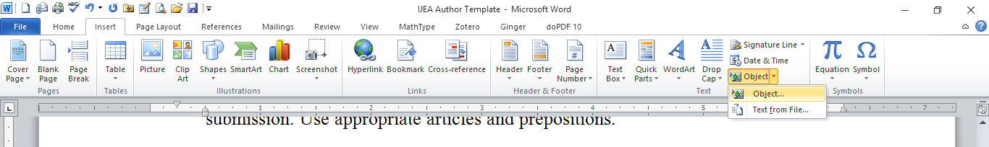

- Main menu screenshot of adding equations
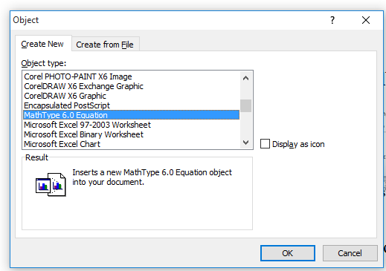
- Object screen screenshot of adding equations
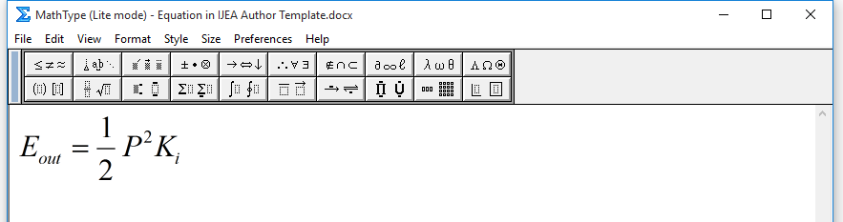
- Mathtype pop up window
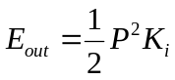 (1)
- CONCLUSION
Conclusions should not a repetition of sentences from the Abstract and body text. Do not add unimportant statements of your results in this section. It should summarize the most important clear scientific results of the research work, their novelty, benefits and limitations.

ACKNOWLEDGEMENT
Acknowledgments of grants, funds, etc. should be placed here. The names of funding organizations should be written in full.

REFERENCES
- Le U. Miu, Rozek J. Pome. Separation of background and target signals in radar cross section measurements. International Journal of Engineering Archives. 2024; 03 (8): 201-206. DOI: 10.1040/0735-7036.122.4.441
- Le U. Miu, Rozek J. Pome. Socioeconomic impacts of biofuel production from lignocellulosic biomass. International Conference of Engineering, London, United Kingdom, 14-15 April 2022. AIP Conference Proceedings. 201-206. DOI: 10.1040/0735-7036.122.4.441
- Le U. Miu, Rozek J. Pome. Mechanics of engineering. 5th ed. New York: John Wiley and Sons; 2019.
- Le U. Miu. Alternative Materials for Bridge Structures. In: Rozek J. Pome and Yan L., editors. Advanced Materials in Civil Engineering. 3rd edition. London, Elsevier; 2021: 48-57.
- Rozek J. Pome. The Beginning Wireless communication, Dr. Rozek J. Pome, 2018. Retrieved from: http://www.education.org /home.html; Accessed 10 Feb 2024.

